Which one of the following calling methods does not change the original value of the argument
in the calling function?
► None of the given options
► Call by passing the value of the argument
► Call by passing reference of the argument
► Call by passing the address of the argument
2. What is difference between call by reference and call by value?
3. What is the maximum depth of recursive calls a function may make?
► 1
► 2
► n (where n is the argument)
► There is no fixed maximum
4. The expression AB+C* is called ?
► Prefix expression
► Postfix expression
► Infix expression
► None of these
5. Please consider the following AVL tree.
1. Insert new node 87 in this tree and make tree balance.
2. Write balance factor of each node after and before inserting node 87.
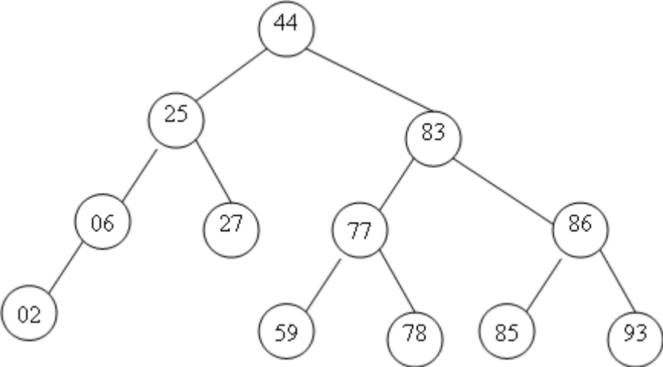

6.. Below is a binary search tree. If we delete the value 50 using the algorithm we discussed, what
value will be in the root of the remaining tree?
► 50
► 60
► 70
► 80
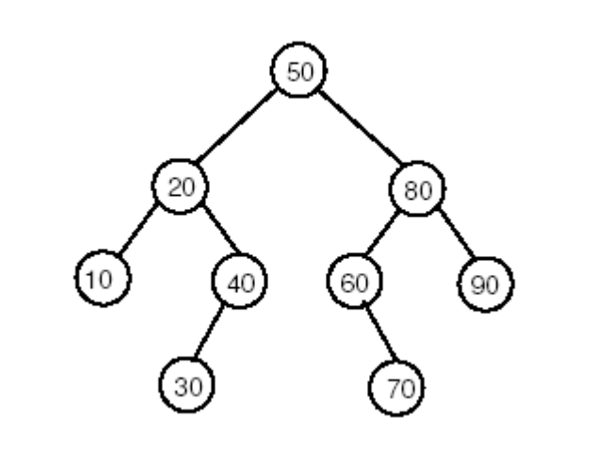

7…In which of traversal method, recursion can not be applied.?
8’’’Reference Variables.

9….WHAT WILL BE THE INFIX EXPRESSION’
Ab+c*d-
Abc*+d-
Abc+*d-
Abcd+*-

